# Efficient Summaries with Custom Functions (Updated Solution)

This document includes the question, the solution, and a breakdown of the code provided in the screenshot.

## Uploaded Screenshot

Below is the screenshot of the task:

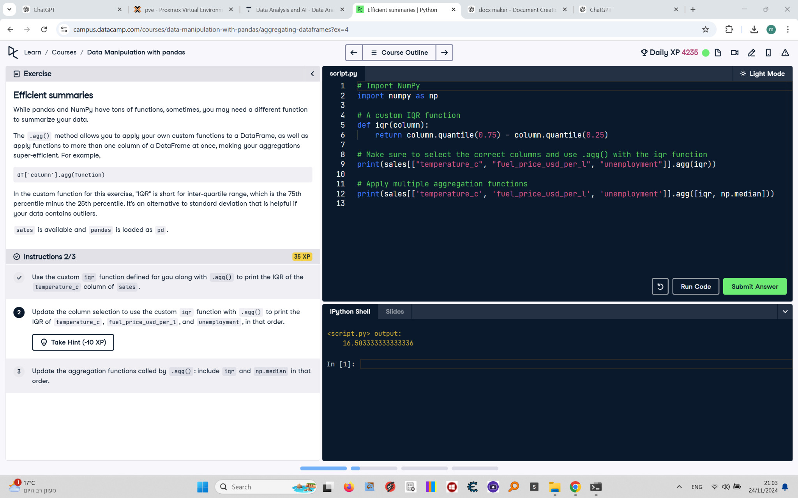

## Question

Update the column selection to use the custom `iqr` function with `.agg()` to print the IQR of `temperature_c`, `fuel_price_usd_per_l`, and `unemployment`, in that order.

## Answer

# Import NumPy  
import numpy as np  
  
# A custom IQR function  
def iqr(column):  
 return column.quantile(0.75) - column.quantile(0.25)  
  
# Aggregate the selected columns using the iqr function  
print(sales[['temperature_c', 'fuel_price_usd_per_l', 'unemployment']].agg(iqr))

## Code Explanation

# Explanation of the code:

1. `import numpy as np`: Imports the NumPy library. Even though not needed for this specific part, it's a good practice to import it for later use.

2. `def iqr(column):`: Defines a custom function `iqr` to calculate the interquartile range (IQR) of a column by subtracting the 25th percentile from the 75th percentile.

3. `sales[['temperature_c', 'fuel_price_usd_per_l', 'unemployment']].agg(iqr)`: Applies the `iqr` function to the selected columns (`temperature_c`, `fuel_price_usd_per_l`, and `unemployment`) in the `sales` DataFrame and prints the results in the specified order.